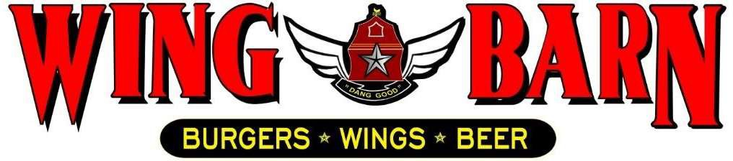

JOB DESCRIPTION
Wing Barn Grill Cook

SUMMARY:

We are searching for an accomplished grill cook to create meals in accordance with customers' preferences. The grill cook's responsibilities include preparing ingredients, informing waitstaff when orders are ready, and cleaning the grill after each shift. The Grill Cook may be assigned in different stations according to the business day. In addition, they aid in the preparation of food during slow business periods. You should also monitor inventory to ensure that you always have sufficient supplies. To be successful as a grill cook, you should be a skilled multitasker who adheres to food safety codes.

RESPONSIBLITIES INCLUDE:

- Assumes 100% responsibility for quality of products served.
- Ensure that food comes out simultaneously, in high quality and in a timely fashion. Comply with sanitation and food safety regulations and standards.
- Knows and complies consistently with our standard portion sizes, cooking methods, quality standards and kitchen rules, policies, and procedures.
- Stocks and maintains enough levels of food products and supplies on the line 15 minutes prior to service.
- Follows proper plate presentation and garnish set up for all dishes.
- Slicing, cutting, shredding, tenderizing, and skewering meat and vegetables
- Handles, stores, and rotates all products properly.
- Assists in food preparation assignments during off-peak periods as needed.
- Follows the openings and closing checklist for assigned kitchen stations.
- Attends all scheduled employee meetings and brings suggestions for improvement.
- Immediately ask the Kitchen Manager or manager-on-duty about menu specials or any other menu issues you should be aware of.
- Clean as you go – maintain a clean and organized station and work area throughout the day.
- Be a team player – support and assist your fellow team members whenever possible in whatever functions are required.
- Do not work more than scheduled hours unless directed by management.
- Always check with Kitchen Manager or General Manager prior to clocking out.
- Maintain a positive and professional approach with coworkers and customers.
PERSONAL REQUIREMENTS:
- Self-discipline, initiative, leadership ability and outgoing. Pleasant, polite manner and a neat and clean appearance.
- Ability to motivate employees to work as a team to ensure that food and service meet appropriate standard.
- Must be able to handle the pressures of simultaneously coordinating a wide range of activities and recommend appropriate solutions to restaurant problems.
- Must possess good communication skills for dealing with diverse staff.
- Ability to coordinate multiple tasks such as food, beverage and labor cost while maintaining required standards of operation in daily restaurant activities.

ACCOUNTABILITIES:
- Keeps General Manager and Kitchen Manager promptly and fully informed of all issues (i.e. problems, unusual matters of significance and positive events) and takes prompt corrective action where necessary or suggests alternative courses of action.
- Completes job responsibilities and performance objectives in a timely and effective manner and in accordance with Wing Barn policies and procedures.
- Maintains a favorable working relationship with all company employees to foster and promote a cooperative and harmonious working climate which will be conducive to maximum employee morale, productivity and efficiency/effectiveness.
- Performs other duties and responsibilities as required or requested.

WORKING CONDITIONS:
- Hours may vary if employee must fill in for his/her employees or if emergencies arise (typical work week = 20-35 hours).
- Ability to perform all functions at the restaurant level.
- Position requires prolonged standing, bending, stooping, twisting, lifting products and supplies weighing 45 pounds, and repetitive hand and wrist motion.
- Work with hot, cold, and hazardous equipment as well as operating phones, computers, copiers, and other office equipment.

