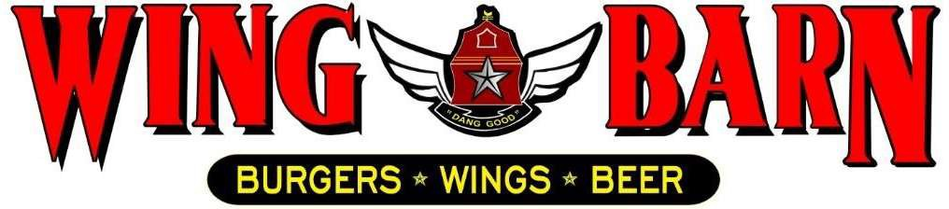

JOB DESCRIPTION
Wing Barn Fry Cook

SUMMARY:

We are seeking a hard-working Fry Cook to join our restaurant team. In this role, you will set up and break down the frying station and assist with prep work. You will then fry food to fulfill orders throughout your shift. Applicants should have some culinary training or restaurant experience, although we are willing to train the right candidate who knows basic cooking techniques and equipment. Working in a kitchen can be stressful, so we are looking for individuals who can remain calm under pressure.

RESPONSIBLITIES INCLUDE:

- Assumes 100% responsibility for quality of products served.
- Ensure that food comes out simultaneously, in high quality and in a timely fashion. Comply with sanitation and food safety regulations and standards.
- Knows and complies consistently with our standard portion sizes, cooking methods, quality standards and kitchen rules, policies, and procedures.
- Stocks and maintains enough levels of food products, sauces and supplies on the line 15 minutes prior to service.
- Follows proper plate presentation and garnish set up for all dishes.
- Fry food to order.
- Handles, stores and rotates all products properly.
- Assists in food preparation assignments during off-peak periods as needed.
- Follows the openings and closing checklist for assigned kitchen stations.
- Attends all scheduled employee meetings and brings suggestions for improvement.
- Immediately ask the Kitchen Manager or manager-on-duty about menu specials or any other menu issues you should be aware of.
- Clean as you go – maintain a clean and organized station and work area throughout the day.
- Be a team player – support and assist your fellow team members whenever possible in whatever functions are required.
- Do not work more than scheduled hours unless directed by management.
- Always check with Kitchen Manager or General Manager prior to clocking out.
- Maintain a positive and professional approach with coworkers and customers.
PERSONAL REQUIREMENTS:
- Self-discipline, initiative, leadership ability and outgoing. Pleasant, polite manner and a neat and clean appearance.
- Ability to motivate employees to work as a team to ensure that food and service meet appropriate standard.
- Must be able to handle the pressures of simultaneously coordinating a wide range of activities and recommend appropriate solutions to restaurant problems.
- Must possess good communication skills for dealing with diverse staff.
- Ability to coordinate multiple tasks such as food, beverage and labor cost while maintaining required standards of operation in daily restaurant activities.

ACCOUNTABILITIES:
- Keeps General Manager and Kitchen Manager promptly and fully informed of all issues (i.e. problems, unusual matters of significance and positive events) and takes prompt corrective action where necessary or suggests alternative courses of action.
- Completes job responsibilities and performance objectives in a timely and effective manner and in accordance with Wing Barn policies and procedures.
- Maintains a favorable working relationship with all company employees to foster and promote a cooperative and harmonious working climate which will be conducive to maximum employee morale, productivity and efficiency/effectiveness.
- Performs other duties and responsibilities as required or requested.

WORKING CONDITIONS:
- Hours may vary if employee must fill in for his/her employees or if emergencies arise (typical work week = 20-35 hours).
- Ability to perform all functions at the restaurant level.
- Position requires prolonged standing, bending, stooping, twisting, lifting products and supplies weighing 45 pounds, and repetitive hand and wrist motion.
- Work with hot, cold, and hazardous equipment as well as operating phones, computers, copiers, and other office equipment.

