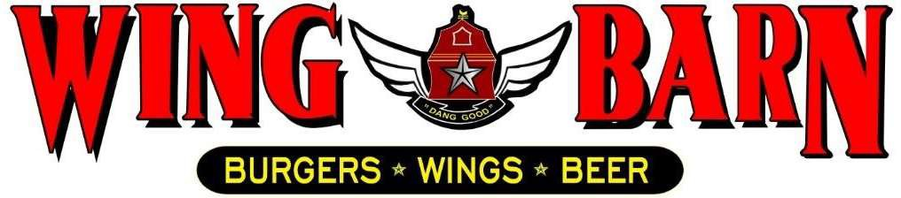

JOB DESCRIPTION
Wing Barn Busser/Runner

SUMMARY:

A Busser, or Food Runner, oversees setting and clearing tables at a dining establishment to provide a clean and tidy environment for restaurant patrons. Their duties include removing used dishes, re-setting silverware and filling beverages for diners.

RESPONSIBLITIES INCLUDE:

Know your schedule. Arrive to your scheduled shift on time (5-10 minutes early).
Removing used baskets and trash from tables after diners are done eating.
Wiping up water spills, food stains and dirt from tables.
Restocking utensils and products at Pepsi station
Refilling drinks
Bringing out meal orders if waitstaff is busy
Understand what the daily specials are and what they cost.
Don’t ever stand around or lean on anything. You can always be cleaning. Clean up, wiping shelves, station, etc
Ensure that there is enough level of product ready in the right storage areas.
Operate phones when needed.
Accept payments, ensuring all prices and quantities are accurate and proving a receipt to every guest. Maintain a clean work area.

PERSONAL REQUIREMENTS:

Self-discipline, initiative, leadership ability and outgoing. Pleasant, polite manner and a neat and clean appearance.
Ability to motivate employees to work as a team to ensure that food and service meet appropriate standard.
Must be able to handle the pressures of simultaneously coordinating a wide range of activities and recommend appropriate solutions to restaurant problems.
Must possess good communication skills for dealing with diverse staff.
Ability to coordinate multiple tasks such as food, beverage and labor cost while maintaining required standards of operation in daily restaurant activities.

ACCOUNTABILITIES:

Keeps General Manager promptly and fully informed of all issues (i.e. problems, unusual matters of significance and positive events) and takes prompt corrective action where necessary or suggests alternative courses of action.
Completes job responsibilities and performance objectives in a timely and effective manner and in accordance with Wing Barn policies and procedures.
Maintains a favorable working relationship with all company employees to foster and promote a cooperative and harmonious working climate which will be conducive to maximum employee morale, productivity and efficiency/effectiveness.
Performs other duties and responsibilities as required or requested.

WORKING CONDITIONS:

Hours may vary if employee must fill in for his/her employees or if emergencies arise (typical work week
= 20-35 hours).
Ability to perform all functions at the restaurant level.
Position requires prolonged standing, bending, stooping, twisting, lifting products and supplies weighing 45 pounds, and repetitive hand and wrist motion.
Work with hot, cold, and hazardous equipment as well as operating phones, computers, copiers, and other office equipment.

