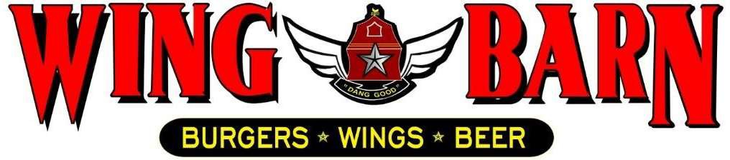

JOB DESCRIPTION

Wing Barn Assistant Kitchen Manager

SUMMARY:

The Assistant Kitchen Manager is responsible for managing the daily operations of our restaurant’s kitchen, under the direction of the general manager. Assisting in selection, development, and performance management of kitchen employees. In addition, they help oversee the inventory and ordering of food and supplies, maximize profits and ensure that customers are satisfied with their dining experience. The Assistant Kitchen Manager will report directly to the General Manager and Kitchen Manager.

RESPONSIBLITIES INCLUDE:
Oversee and manage all areas of the kitchen and make final decisions on matters of importance.

Adhere to kitchen standards and levels to increase sales and minimize cost, waste, including food, beverage, supply utility and labor cost.

Enforce sanitary practices for food handling, general cleanliness and maintenance of the kitchen.

Ensure compliance with operational standards, company policies, federal/state/local laws and ordinances. (WB cleaning list, temp logs, oil log, prep list, food orders, etc.)

Ensure consistent high quality of food preparation and presentation.

Maintain professional image, including kitchen cleanliness, proper uniform of cooks, and appearance standards.

Work with Kitchen Manager for efficient provisioning and purchasing of supplies. Supervise portion control and quantities of presentation to minimize waste.

Estimate food needs, place orders with distributors/General Manager and schedule the delivery of fresh foods and supplies.

Ensure that proper security procedure is in place to protect employees and company assets. Ensure a safe working environment to reduce the risk of injury and accidents.

Complete accident report promptly if the employee is injured.

Manage shifts which include daily decision making, scheduling, planning while upholding standards, product quality and cleanliness.
Investigate and resolve complaints concerning food quality and service.

Provide direction to existing and new employees regarding operations and procedures.

Conduct orientation, explaining the Wing Barn philosophy and oversee the training of new employees.

Develop employees by providing ongoing feedback, establishing performance expectations, and by conducting performance reviews

Maintain an accurate and up-to-date plan of kitchen staffing needs.

Personally, prepare schedules and ensure that the kitchen is staffed for all shifts. Oversee and manage the completion of opening and closing checklists.

Enforce the proper stocking of food products and any equipment needed for station, as well as the rotation of products so that product from the prior shift is used first.

QUALIFICATIONS:
High School Degree or equivalent.
College degree is preferred. Bachelor of Science degree in hotel/restaurant management is desirable. A combination of practical experience and education will be considered as an alternative.
Knowledge of computers (MS Word, Excel).
Proficient in the following dimensions of restaurant functions: food planning and preparation, purchasing, sanitation, security, company policies and procedures, personnel management, recordkeeping, and preparation of reports.

PERSONAL REQUIREMENTS:
Self-discipline, initiative, leadership ability and outgoing. Pleasant, polite manner and a neat and clean appearance.
Ability to motivate employees to work as a team to ensure that food and service meet appropriate standards.
Must be able to handle the pressures of simultaneously coordinating a wide range of activities and recommend appropriate solutions to restaurant problems.
Must possess good communication skills for dealing with diverse staff.
Ability to coordinate multiple tasks such as food, beverage and labor cost while maintaining required standards of operation in daily restaurant activities.

ACCOUNTABILITIES:
Keeps General Manager and Kitchen Manager promptly and fully informed of all issues (i.e. problems, unusual matters of significance and positive events) and takes prompt corrective action where necessary or suggests alternative courses of action. Ability to determine applicability of experience and qualifications of job applicants.
Completes job responsibilities and performance objectives in a timely and effective manner and in accordance with Wing Barn policies and procedures.
Maintains a favorable working relationship with all company employees to foster and promote a cooperative and harmonious working climate which will be conducive to maximum employee morale, productivity and efficiency/effectiveness.
Performs other duties and responsibilities as required or requested.

SUPERVISION OF OTHERS:
10+ employees each shift

WORKING CONDITIONS:
Hours may vary if manager must fill in for his/her employees or if emergencies arise (typical work week = 45-50 hours).
Ability to perform all functions at the restaurant level, including delivery when needed.
Position requires prolonged standing, bending, stooping, twisting, lifting products and supplies weighing 45 pounds, and repetitive hand and wrist motion.
Work with hot, cold, and hazardous equipment as well as operating phones, computers, fax machines, copiers, and other office equipment.

