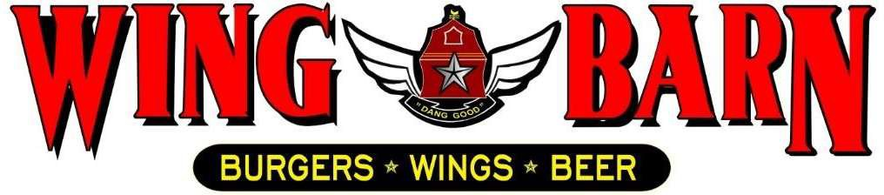

JOB DESCRIPTION
Wing Barn Assistant
General Manager

SUMMARY:
The Assistant General Manager is responsible for managing the daily operations of our restaurant, including the selection, development and performance management of employees. In addition, they oversee the inventory and ordering of food and supplies, maximize profits and ensure that customers are satisfied with their dining experience. The General Manager will report directly to the District Manager.

RESPONSIBLITIES INCLUDE:
Oversee and manage all areas of the restaurant and make final decisions on matters of importance.
Adhere to company standards and service levels to increase sales and minimize costs, including food, beverage, supply, utility and labor costs.
Responsible for ensuring that all financial (invoices, reporting) and personnel/payroll related administrative duties are completed accurately, on time and in accordance with company policies and procedures.
Enforce sanitary practices for food handling, general cleanliness, and maintenance of kitchen and dining areas. Ensure compliance with operational standards, company policies, federal/state/local laws, and ordinances.
Responsible for ensuring consistent high quality of food preparation and service.
Maintain professional restaurant image, including restaurant cleanliness, proper uniforms, and appearance standards.
Estimate food and beverage costs. Work with District Manager for efficient provisioning and purchasing of supplies. Supervise portion control and quantities of preparation to minimize waste.
Estimate food needs, place orders with distributors/General Managers, and schedule the delivery of fresh food and supplies.
Must be SERV Safe certified.
Will uphold all SERV Safe guidelines.
Ensure positive customer service in all areas. Respond to complaints, taking any and all appropriate actions to turn dissatisfied customers into return customers.
Ensure that proper security procedures are in place to protect employees, customers and company assets. Ensure a safe working and customer environment to reduce the risk of injury and accidents.
Completes accident reports promptly in the event that a customer or employee is injured.

Manage shifts which include daily decision making, scheduling, planning while upholding standards, product quality and cleanliness.
Investigate and resolve complaints concerning food quality and service Provide direction to employees regarding operational and procedural issues.
Interview hourly employees. Direct hiring, supervision, development and, when necessary, termination of employees.
Conduct orientation explain the Wing Barn Philosophy and oversee the training of new employees.
Develop employees by providing ongoing feedback, establishing performance expectations and by conducting performance reviews.
Maintain an accurate and up-to-date plan of restaurant staffing needs.
Personally, prepare schedules and ensure that the restaurant is staffed for all shifts.

QUALIFICATIONS:
High School Degree or equivalent.
College degree is preferred. Bachelor of Science degree in hotel/restaurant management is desirable. A combination of practical experience and education will be considered as an alternative.
Knowledge of computers (MS Word, Excel).
Proficient in the following dimensions of restaurant functions: food planning and preparation, purchasing, sanitation, security, company policies and procedures, personnel management, recordkeeping, and preparation of reports.
Must possess a valid driver’s license.
Must be eligible to work in the United States. Must agree to background and credit check.

PERSONAL REQUIREMENTS:
Self-discipline, initiative, leadership ability and outgoing. Pleasant, polite manner and a neat and clean appearance.
Ability to motivate employees to work as a team to ensure that food and service meet appropriate standards.
Must be able to handle the pressures of simultaneously coordinating a wide range of activities and recommend appropriate solutions to restaurant problems.
Must possess good communication skills for dealing with diverse staff.
Ability to coordinate multiple tasks such as food, beverage and labor cost while maintaining required standards of operation in daily restaurant activities.

ACCOUNTABILITIES:
Keeps General Manager promptly and fully informed of all issues (i.e. problems, unusual matters of significance and positive events) and takes prompt corrective action where necessary or suggests alternative courses of action. Ability to determine applicability of experience and qualifications of job applicants.
Completes job responsibilities and performance objectives in a timely and effective manner and in accordance with Wing Barn policies and procedures.
Maintains a favorable working relationship with all company employees to foster and promote a cooperative and harmonious working climate which will be conducive to maximum employee morale, productivity and efficiency/effectiveness.
Performs other duties and responsibilities as required or requested.

SUPERVISION OF OTHERS:
10+ employees each shift

WORKING CONDITIONS:
Hours may vary if manager must fill in for his/her employees or if emergencies arise (typical work week = 50-55 hours).
Ability to perform all functions at the restaurant level, including delivery when needed.
Position requires prolonged standing, bending, stooping, twisting, lifting products and supplies weighing 45 pounds, and repetitive hand and wrist motion.
Work with hot, cold, and hazardous equipment as well as operating phones, computers, fax machines, copiers, and other office equipment.

